Hanukkah 8k course
 | direction | location
 | start | 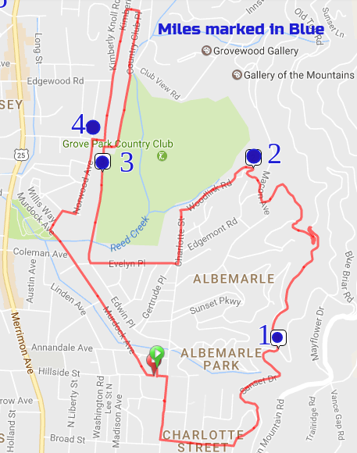  JCC parking lot
 | left | onto Hillside
 | right | onto Charlotte
 | left | onto Baird
 | left | onto Sunset Drive
 | bear L | staying on Sunset
 | bear L | staying on Sunset
 | bear R | staying on Sunset
 | left | onto Howland Road
 | straight | onto Sunset Trail
 | right | onto Macon Avenue
 | left | onto Sunset Terrace
 | follow | Driving arrows thru cottages
 | straight | onto Woodlink Road
 | left | onto Charlotte
 | right | onto Evelyn Place
 | right | onto Kimberly Avenue
 | right | onto Country Club Road
 | left | onto Country Club Place
 | left | onto Sedley Street
 | left | onto Kimberly Avenue
 | right | onto Farrwood Avenue
 | left | onto Norwood Avenue
 | right | to stay on Norwood Avenue
 | left | to stay on Norwood Avenue
 | left | onto Murdock Avenue
 | left | onto Hillside
 | left | into JCC parking lot

2 water stops along the way- stay hydrated
Stay Safe and Have Fun

